# Count the total number of rentals by day of the week

Question Screenshot:

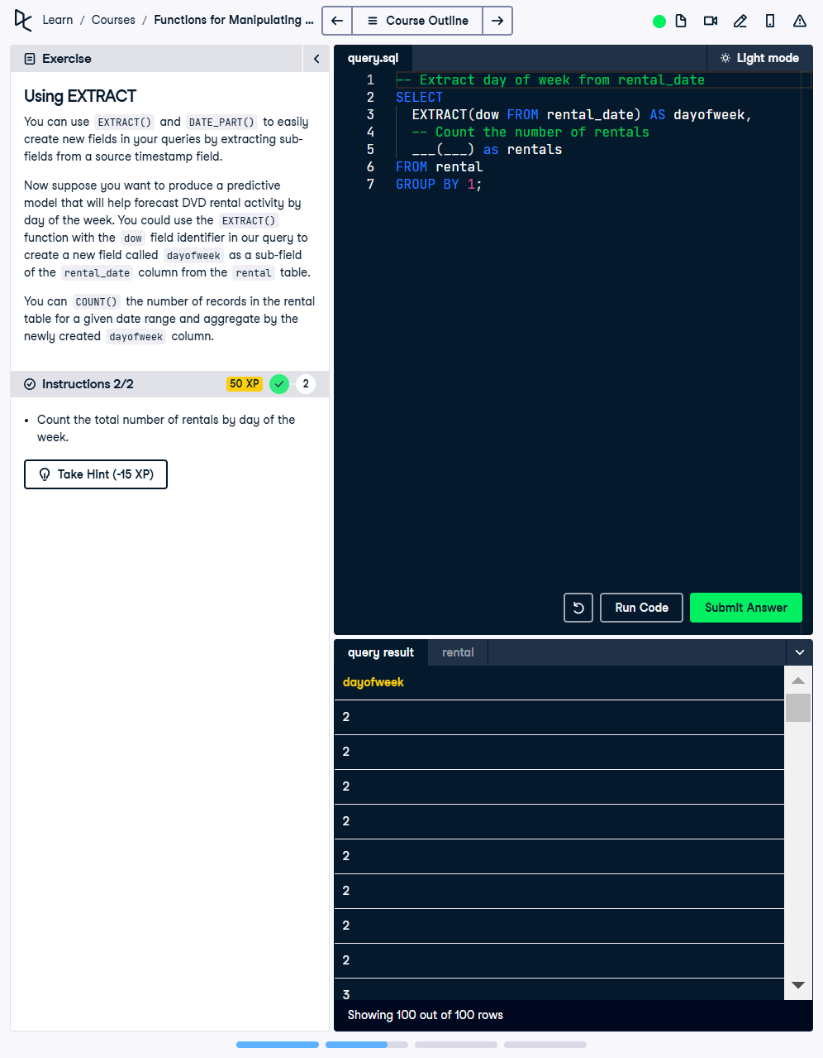

Question:  
Using EXTRACT  
You can use EXTRACT() and DATE_PART() to easily create new fields in your queries by extracting subfields from a source timestamp field.  
  
Now suppose you want to produce a predictive model that will help forecast DVD rental activity by day of the week. You could use the EXTRACT() function with the dow field identifier in our query to create a new field called dayofweek as a sub-field of the rental_date column from the rental table.  
  
You can COUNT() the number of records in the rental table for a given date range and aggregate by the newly created dayofweek column.  
Instruction:  
Count the total number of rentals by day of the week.

Answer:

SELECT   
 EXTRACT(DOW FROM rental_date) AS dayofweek,  
 COUNT(*) AS rentals  
FROM rental  
GROUP BY 1;

Explanation:

1. SELECT EXTRACT(DOW FROM rental_date): Extracts the day of the week (DOW) from the rental_date column.  
2. COUNT(*) AS rentals: Counts the total number of records for each day of the week.  
3. GROUP BY 1: Groups the query result by the extracted day of the week to calculate counts for each day.